Install Nginx
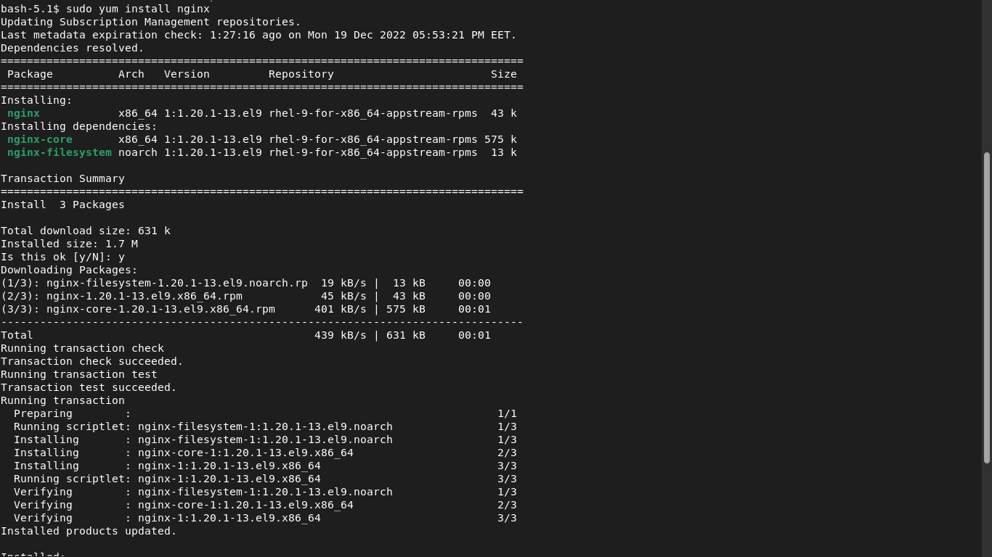
Change the default file (index.html) to (yourName.html)
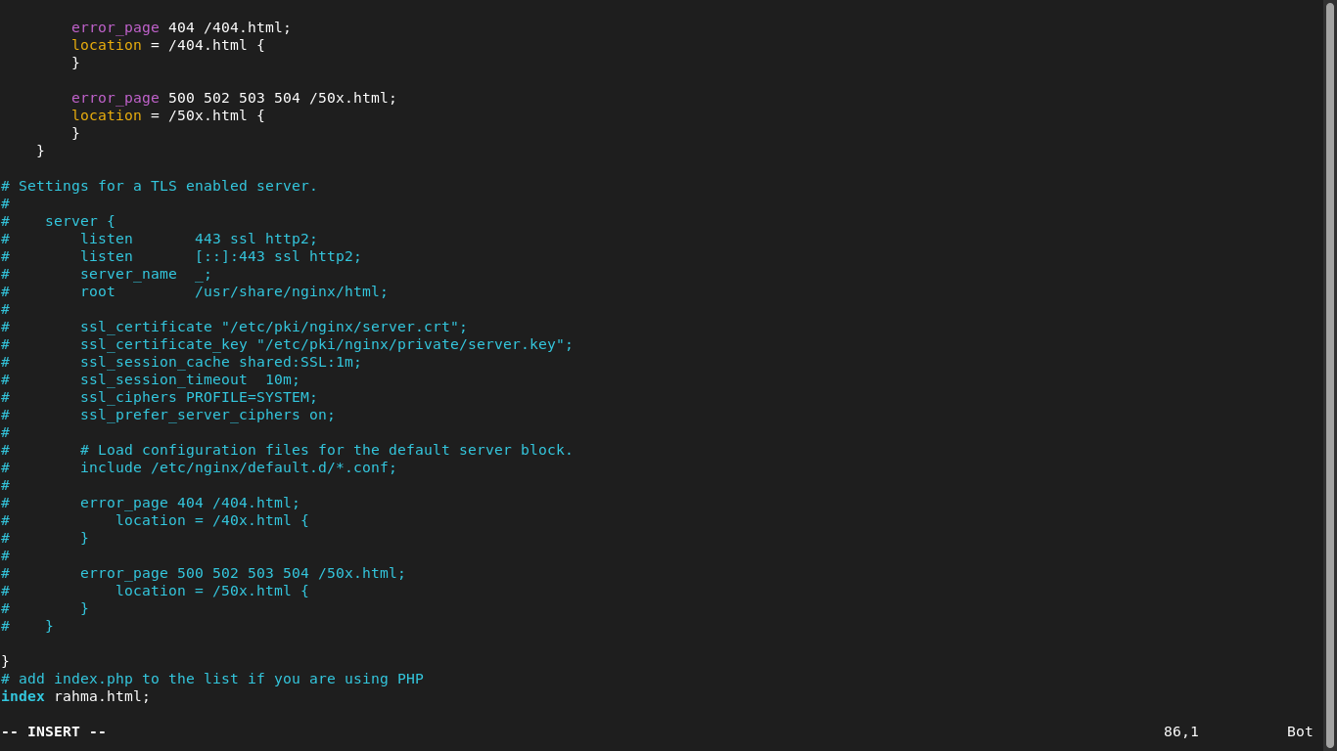
Make two html files, and change the configuration file to access the first file on port 81, and access the second file on port 82.
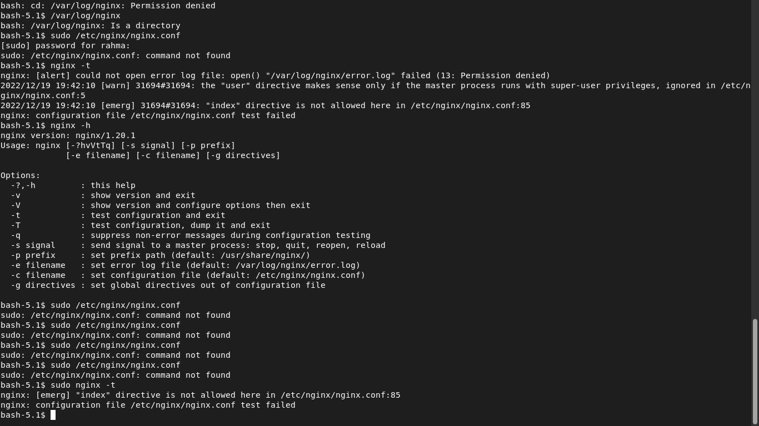

Tell me the main differences between Apache & Nginx

S.NO. | Apache | Nginx
1. | Apache is an open-source web server. | Nginx is a web server. It is also used as a reverse proxy server which revices the request from client and send the request to proxy server.
2. | It is mostly used for Unix, Linux, Windows and Solaris platforms. | It is mostly used for Unix like systems, and does not completely support Windows.
3. | It was developed by Apache group and initially released on 25 March 1999. | It was developed by Nginx.inc and initially released on 4 october 2004.
4. | Apache is written in C and XML. | Nginx is written in C language.
5. | It is designed for web server. | It is designed for proxy server as well as web server.
6. | In heavy web traffic, it cannot support multiple requests. | It can support multiple client requests with limited hardware resources.
7. | In Apache, modules are dynamically fixed that make it more complex. | In Nginx, modules cannot be loaded dynamically as there is a core software in which they are complied .
8. | It follows Multi-Threaded approach to process client requests. | It follows Event-Driven approach to process client requests.
9. | In Apache, there is a dynamic content in web server itself. | It does not support provide dynamic content.
10. | Apache’s performance for static content is lower than that of Nginx. | Nginx’s performance of static content is two times faster than that of Apache as it can simultaneously run thousands of connections and it uses less memory comparatively.
11. | Less security provided as compared to Nginx and also the codebase is very high. | It provides better security with a smaller codebase.
12. | File system location are passed to interpret the client requests. | It passes Uniform Resource Identifier (URI) to interpret the client requests.
13. | Complex configuration system as compared to Nginx. | It has relatively simpler configuration system.

